**EARTHQUAKE PREDICTION MODEL USING PYTHON**

**Program:**

import pandas as pdd

import numpy as npp

import matplotlib.pyplot as pltt

import seaborn as sbb

df1 = pdd.read_csv('/content/drive/MyDrive/Csvfiles/earth.csv')

df1.shape

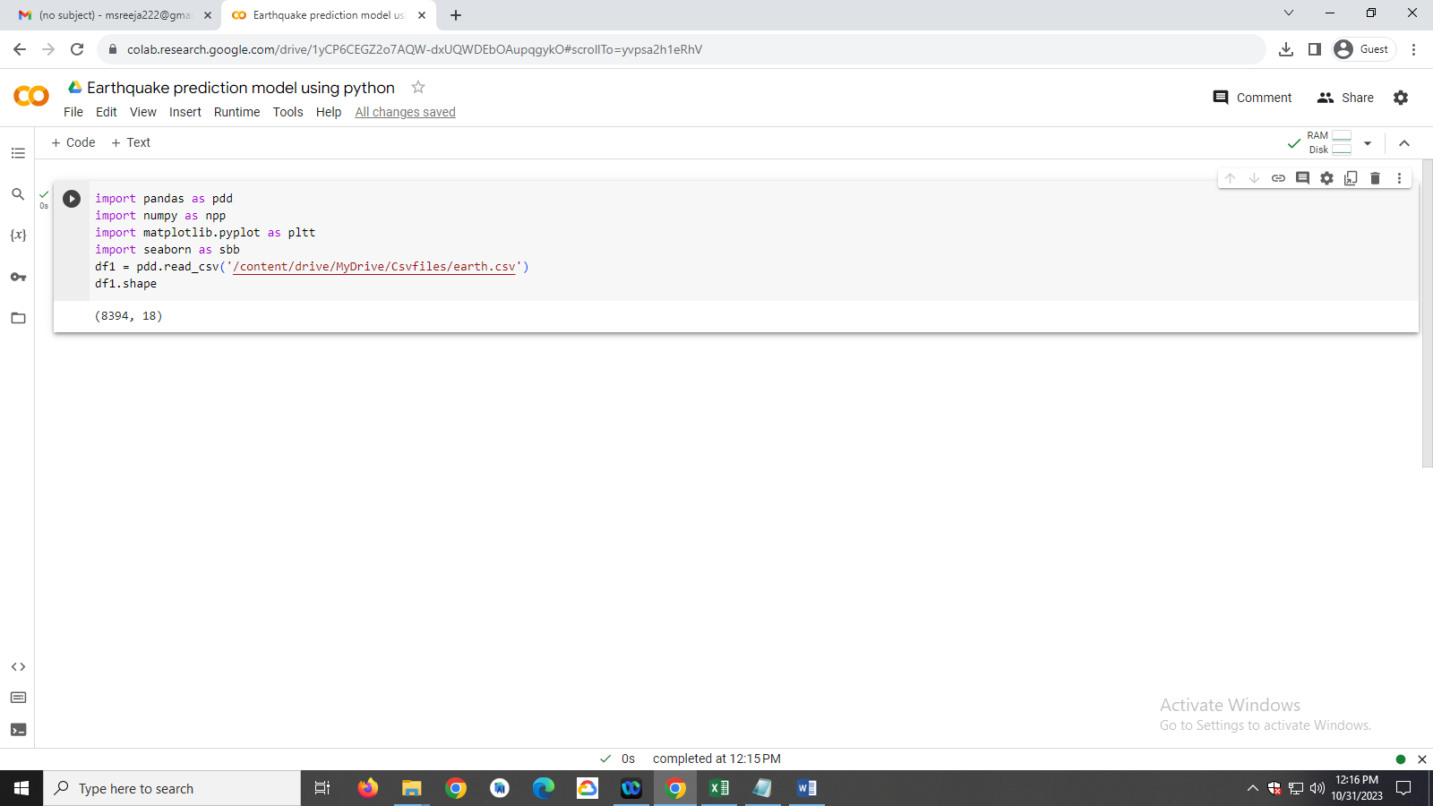

[df1.info](http://df1.info/)()

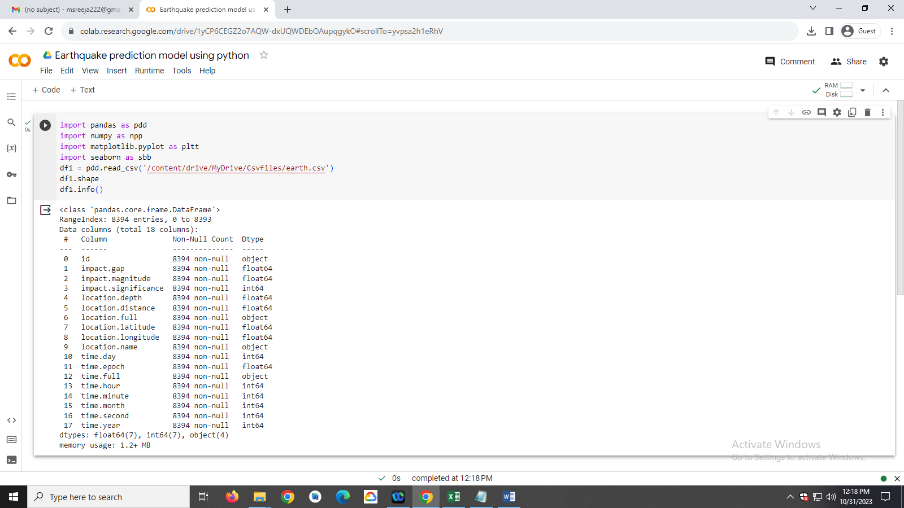

df1.describe()

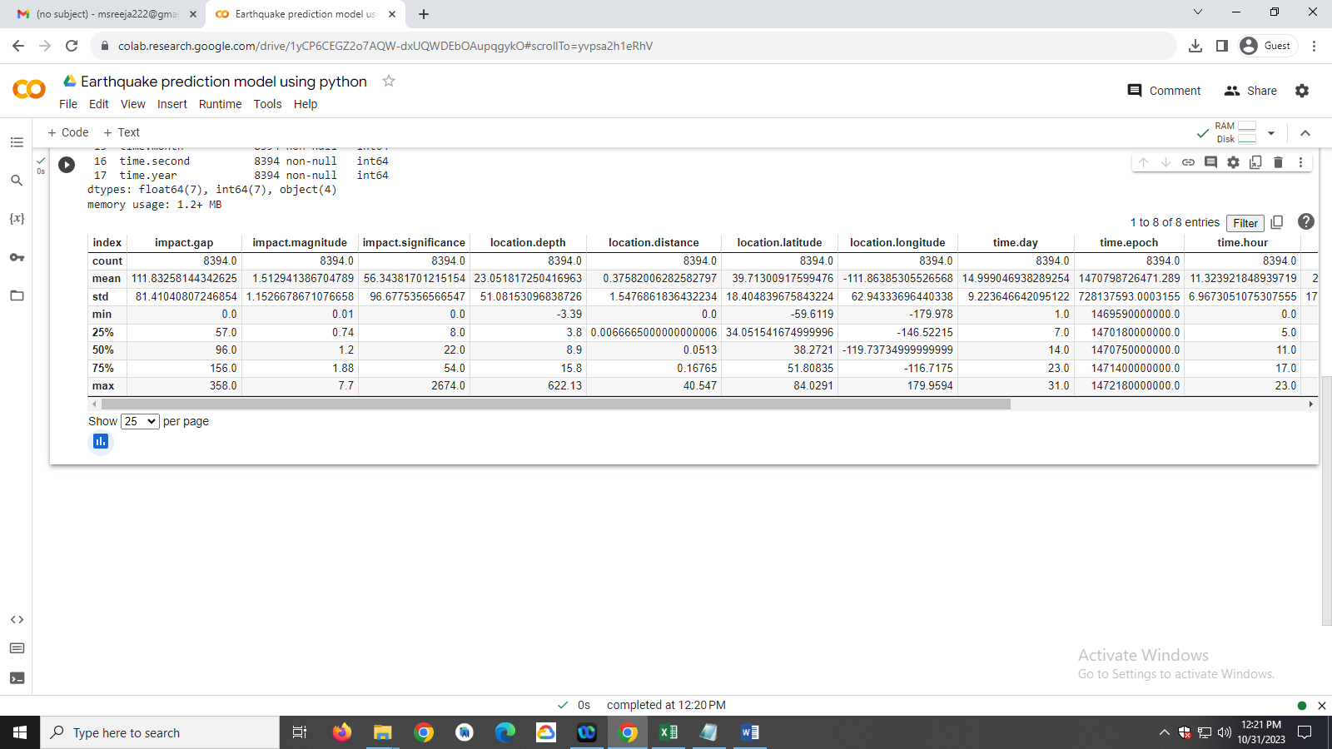

pltt.figure(figsize=(10, 5))

x1 = df1.groupby('time.year').mean()['location.depth']

x1.plot.bar()

pltt.show()

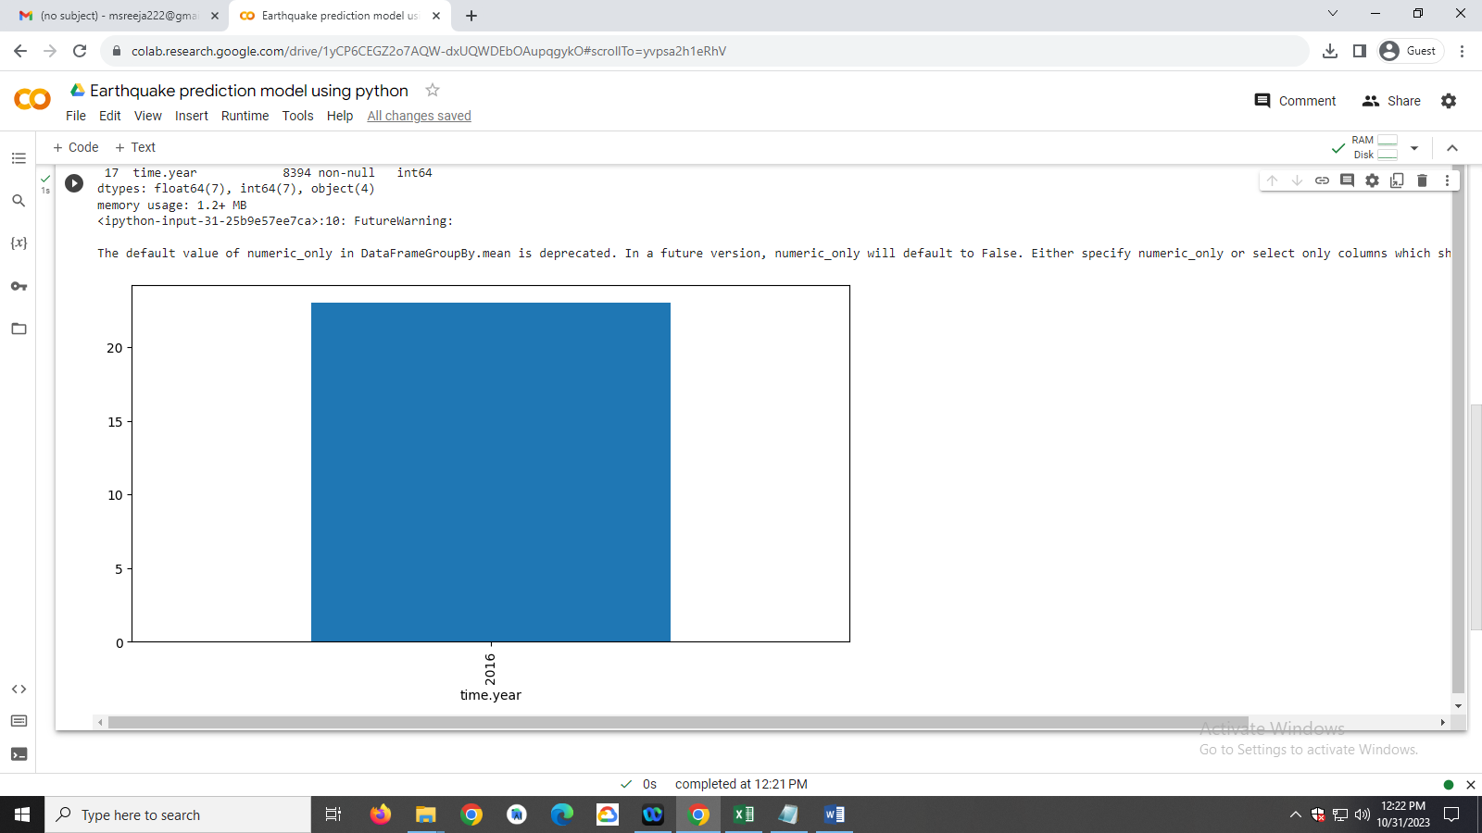

fig1 = pltt.figure()

ax1 = fig1.add_axes([.1, .1, 2, 1])

ax1.plot(df1['impact.magnitude'])

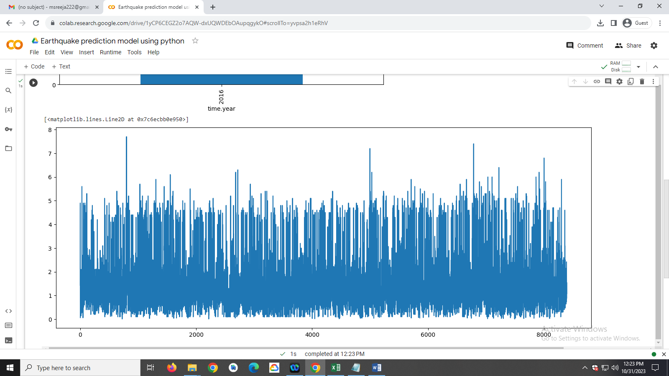

pltt.figure(figsize=(10, 5))

sbb.lineplot(data=df1,x='time.month',

y='impact.magnitude')

pltt.show()

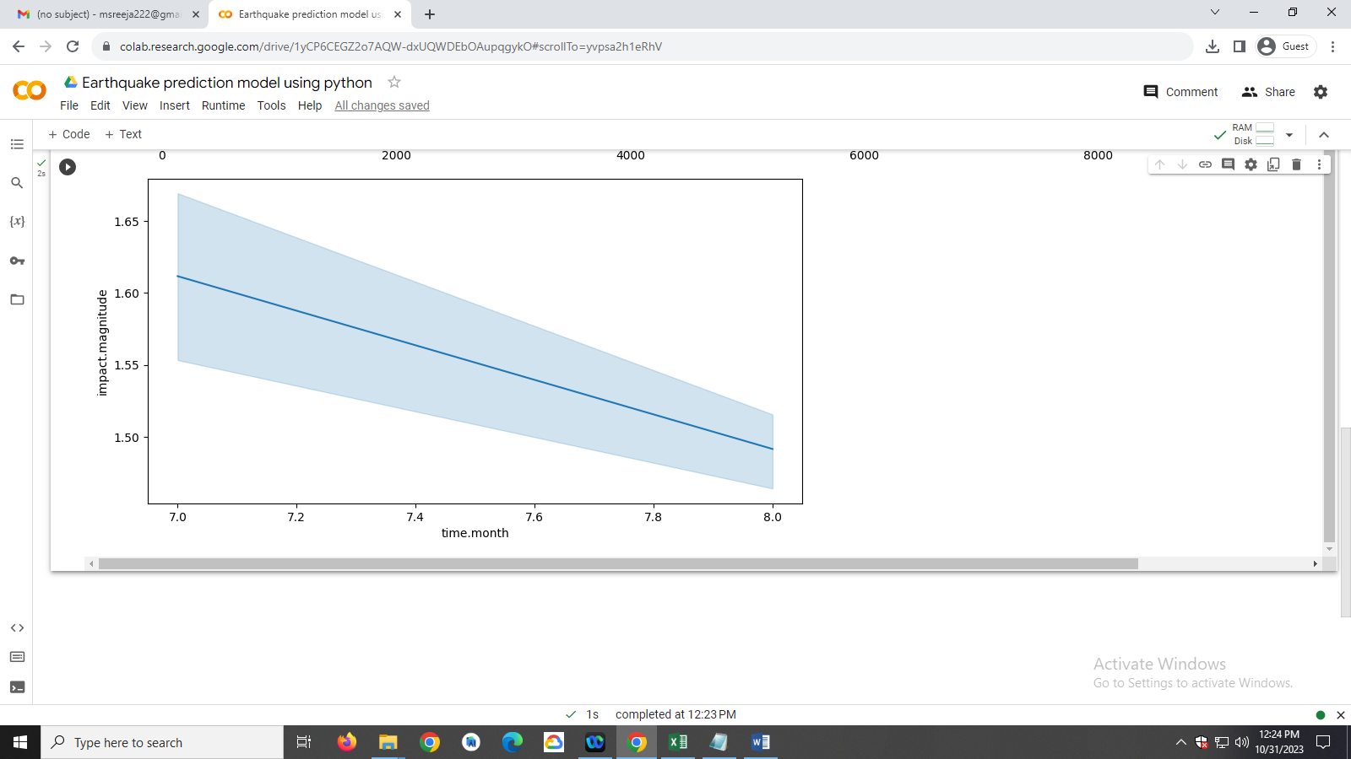

pltt.subplots(figsize=(15, 5))

pltt.subplot(1, 2, 1)

sbb.distplot(df1['location.depth'])

pltt.subplot(1, 2, 2)

sbb.boxplot(df1['location.depth'])

pltt.show()

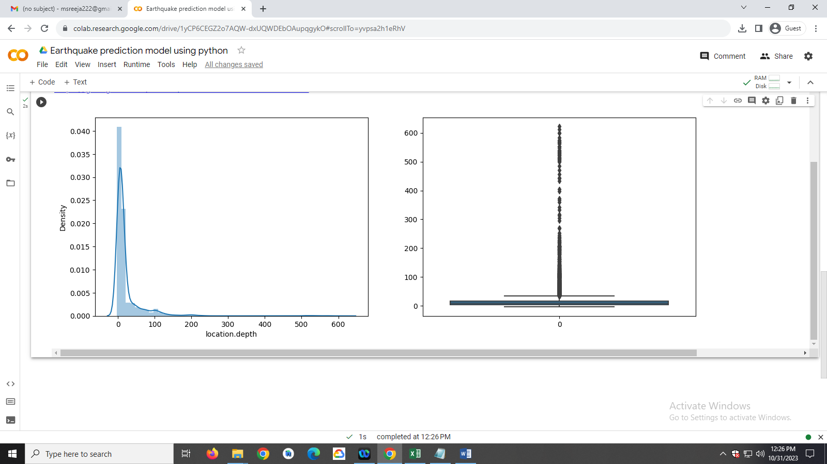

pltt.subplots(figsize=(15, 5))

pltt.subplot(1, 2, 1)

sbb.distplot(df1['impact.magnitude'])

pltt.subplot(1, 2, 2)

sbb.boxplot(df1['impact.magnitude'])

pltt.show()

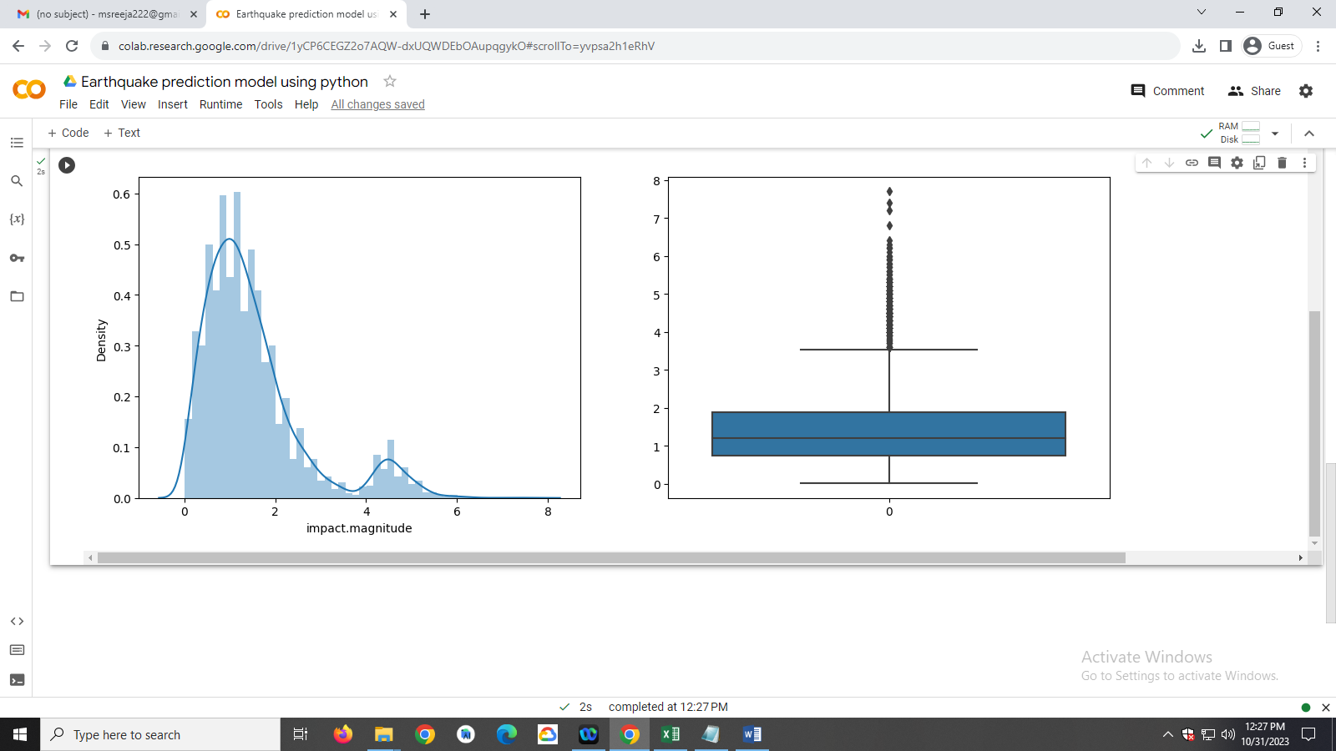

pltt.figure(figsize=(20, 10))

sbb.scatterplot(data=df1,

   x='location.latitude',

   y='location.longitude',

   hue='impact.magnitude')

pltt.show()

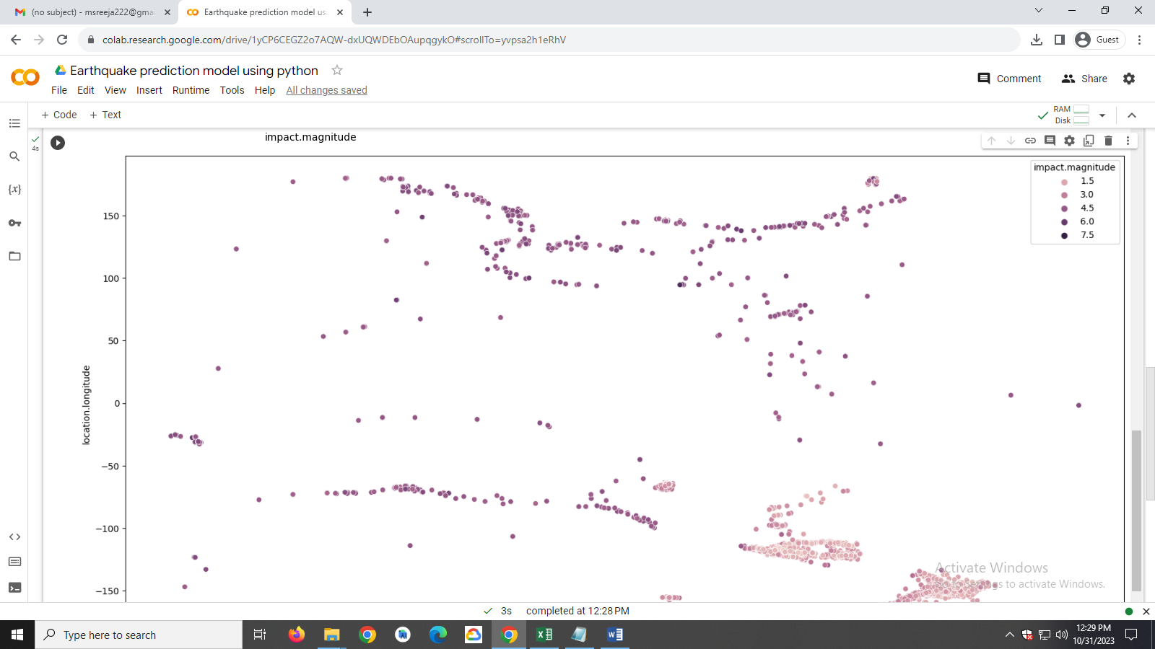

import plotly.express as pxx

import pandas as pdd

fig_w = pxx.scatter_geo(df1, lat='location.latitude',

   lon='location.longitude',

   color="impact.magnitude",

   scope='usa')

fig_w.show()

